National University of Computer and Emerging Sciences


In-Lab 6 Exercise

“Nested Queries”
Database Systems

Spring 2023

Department of Computer Science
FAST-NU, Lahore, Pakistan

Schema:
For this exercise use the following schema, the script to create this schema and populate data is given in Twitter.SQL file.
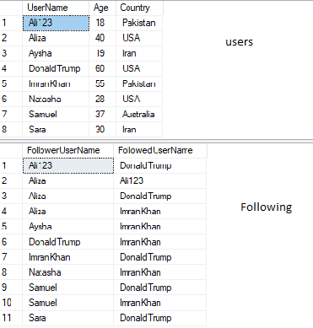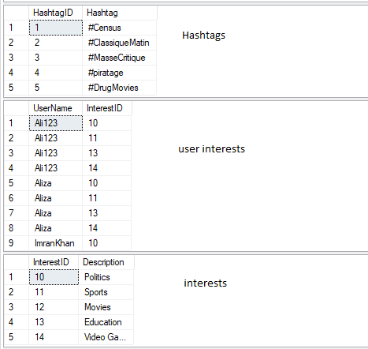
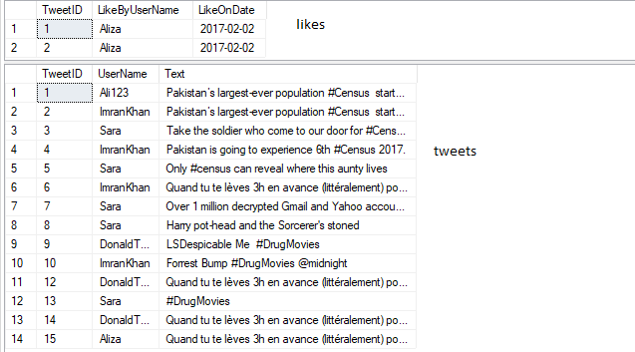
Exercise:
- Give name of the user who has the highest number of followers.
- Give name of the user who has second highest followers.
- List names of all the users who have never tweeted.
- List all the hashtags and usernames and number of times that user used that hashtag.
- Find the users who have never used the hashtag #Census.
- List all the usernames that have never been followed. Using Set operation
- List all the usernames that have never been followed. Using Exist Clause.
- Find the most common interest of users. (The interest with largest number of users). Also find the least common interest.
- Show total tweets per country. The result should be in order of country name.
- List names of all the users whose number of tweets is more than average number of tweets per user.
- Give the name of the users who have at least one follower from Pakistan.

